HLD document contains:

Architecture
Services
Databases
Communication
Kafka
Security
External systems
Deployment
Scalability

Architecture:

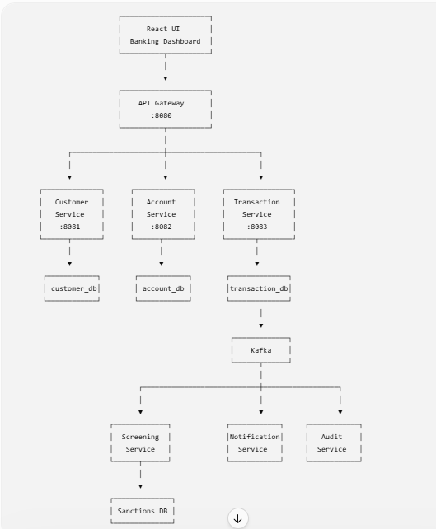

React
↓
Customer Service
↓
Customer DB

React
↓
Account Service
↓
Account DB

